14: Creating a Virtual Hard Disk Using VMware Workstation
1. Aim
To create a Virtual Hard Disk (VHD) and allocate storage space using VMware Workstation.
2. Procedure
- Open VMware Workstation on the host computer.
- Select Create a New Virtual Machine.
- Choose the required configuration option.
- Select the Windows/Linux operating system ISO file.
- Enter the Virtual Machine name and storage location.
- Open the Specify Disk Capacity option.
- Enter the required virtual disk size (e.g., 15GB).
- Select the disk storage option (single file or multiple files).
- Click Next and then Finish.
- The virtual hard disk will be created and allocated to the Virtual Machine.
- Verify the disk capacity in the VM settings.
IMPLEMENTATION
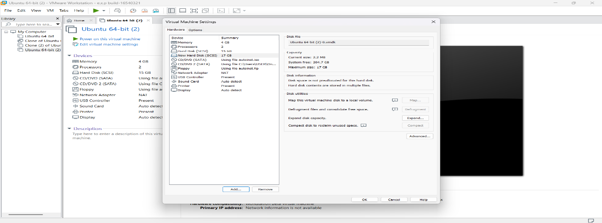
Result
Thus, a Virtual Hard Disk was successfully created and storage space was allocated using VMware Workstation.

